

**e-Yantra Robotics Competition - 2018**

**Theme and Implementation Analysis – Ant Bot**

**<2121>**

|  |  |
| --- | --- |
| **Team leader name** | Tamsil Sajid Amani |
| **College** | Jamia Millia Islamia |
| **Email** | tamsajama@gmail.com |
| **Date** | 01-01-2019 |

**Scope and Preparing the Arena**

**Q1. a. State the scope of the theme assigned to you.**

**(5)**

The Ant-Bot theme assigned to us is basically a representation of how an ant works. Our robot (i.e. Ant-bot) is an ant and has to perform specific tasks which are a characteristic of a normal ant. Such as supplying food to ant hills, removing waste from them, etc.

Ant-bot is useful in the following domains: -

1. Supply of materials at construction sites –

We can use our ant-bot and program it in such a way that it knows which supply material are to be transported to which construction areas.

1. In mining where there is danger/risk to human life.
2. Modern-day labourer –

Instead of manual labour (coolie system) at railways, etc. we can have ant-bots.

1. Serving food from kitchen counters to customer tables.

**b. Upload the Final Arena Images.**

**(20)**

< Prepare the arena according to the steps given in Section 4: Arena, of the Rulebook. Please follow the sample SIM Placement Document (provided in Task 2) and example Supply Placement Table and Trash Placement Table in section 3: Theme Description of arena. Your final arena should look like as shown in Figure 7 of Rulebook.

**Take 4 photos** of the completed arena from different angles such that the entire arena along with its components such as SIMs, Supply Blocks, Trash Blocks, AH Walls, etc., are clearly visible in the photos.

Answer Format: The four image files should be uploaded as **.jpg** along with this document as per instructions in Read Me for Task 3. >

**Building Modules**

**Q2. Identify the major components required for designing the robotic system for the theme assigned to you.**

**(5)**

For Ant-bot, the major components required are: -

ELECTRONIC:

1. White Light Sensor –

A 3-channel white line sensor is used. This sensor gives 0.18 volts on bright surface and gives 2.2V or more on the dark surface. With its help, we will detect the ‘black’ path and move our robot respectively.

1. Processing Unit (Arduino Nano) –

It’s a micro-controller board. Based on the input readings from the line sensor, it will send output signals to the Standard and Micro Servo motors, the Motor driver (L298N) (through Raspberry Pi).

1. Motor Driver (L298N) –

It is used to provide 12V power to the two DC motors. It receives signals from the Raspberry pi, and upon detection of a black path the DC motors start to rotate.

1. Camera (PiCam) –

A simple high definition camera with resolution up to 5MP (megapixels) is used in our theme to detect the Supplies and SIMs (ArucoID) placed on the arena.

1. Power Supply –

We’ll be using an Intex Power bank to provide electric supply to our ant-bot.

MECHANICAL:

1. Actuators
   1. DC Motors (for wheels) –

They required for primary motion of the robot along the arena. Once the white light sensor detects a black path, the DC motors start rotating.

* 1. Micro Servo Motor –

It is used for proper orientation and placement of the Supply block in the required 7x7 cm^2 area.

* 1. Standard Servo Motor –

It is used to rotate the ant-bot in the respective direction once it encounters a node.

1. Pick and Place mechanism –

We will use an additional gripper arm for picking up and holding the supply/trash blocks.

This will require an actuator exclusively for the arm’s operation.

**Power Management**

**Q3. a. Explain the power management system required for a robot in general and for the theme assigned to you in particular.**

**(5)**

Power Management in the Ant-bot theme:

1. Standard Servo Motor-

The common RC servo motor require 4-6 Volts and 100mA – 2A of current.

It is connected to the Arduino Nano with 5V power supply.

1. Micro Servo Motor-

It also requires 5V of power supply which is provided by the Arduino Nano.

1. DC motors-

They require 12V of power supply which is provided to them from the Li-ion battery through the L298N motor driver. They require 600 mA of continuous current and 1A of starting current.

1. White Light Sensor-

It requires 3.3V of power which is supplied by the Arduino Nano with an additional supply capacity of 100mA.

1. Buzzer –

It requires 5V of power supply from the Arduino Nano.

**b. Can there be a single power supply for your robot? - Yes/No/Don’t know. Please elaborate/justify your answer choice.**

**(5)**

No.

There cannot be a single power supply source for our robot. The reason being, we have different components which have different power rating at which they are to be operated.

For example,

|  |  |
| --- | --- |
| **Component** | **Rating** |
| DC motors | 12 V |
| White Light Sensor | 3.3 V |
| Servo motors | 5 V |
| Buzzer | 5 V |

Since, a single power source can’t provide variable supplies, hence we need at least two power supplies.

In our Ant-bot theme, we have

1. A **Li-ion battery** which provides a power supply of *12V* needed to run the two DC Motors.
2. And, an **Intex Power Bank** which provides a *5V* supply to power up the Raspberry Pi, Arduino Nano, Motor Drivers, sensors, etc.

**Design Analysis**

**Q4.** **Team have to design a robot which traverses the arena following a given path.**

**a. How will you design a robot to traverse the arena given in the rulebook?**

**(5)**

In our ant-bot theme the robot will work in the following way: -

1. The bot starts from the start position. The line sensors will detect a black path and will give the respective output to the Arduino Nano, which in turn will signal the L298N to drive the DC motors.
2. The motors will rotate and the bot will travel forth.
3. Once the bot reaches the central node, it will stop and depending upon the strategy which we will choose, it will scan the 4 SIM’s for the ArUco ID’s through the PiCam with the help of an actuator.
4. Once the 4 ID’s have been scanned. The algorithm will search for the Queen Ant Hill.
5. Depending upon the service requirement of the QAH, it will be either served first or last.
6. Now, if Service required at an Ant hill is supply, then the bot will traverse back to the supply area and scan for the respective supply. Here also the picam will give a picture of the supplies and the one which matches the requirement will be picked up with the help of Picking mechanism.
7. The bot will now travel to the respective ant hill and after reaching the destination where the supply is required, it will drop the supply.
8. If a service requires a trash to be removed, then the bot will travel to the respective ant hill from the central node and will pick up the trash.
9. It will then travel to the trash zone area and will leave the trash. Here it is required that the trash must be inside the zone area and not outside.
10. Once all the services of the 4 ant hills have been completed, the robot will return to the start position and the buzzer of be turned ON for 5 seconds indicating the end of the RUN.

**b. How many actuators do you feel are sufficient for designing a pick and place mechanism? If you are going to use additional actuators (apart from those provided in the kit), how and for what purpose do you plan to use them?**

**(5)**

We are going to use **2 actuators** for the ‘Pick and Place’ mechanism.

1. Correct Placing Mechanism:

Once we are near the area at which the supply block has to be placed, we will use the ***Micro Servo Motor (Actuator)*** to change the direction/orient the held block in such a way that it gets placed as perfectly as it can within the designated boundary for the supply block in the ant-hill.

Now, an additional actuator will be used for *‘Picking Up, Holding and Placing the blocks’*

1. We will use a Gripper Arm for the pick & place mechanism. A **gripper arm** is a robotic arm which can be used in various pick & place kind of robots. It works on ***DC Motor (Actuator)*** (9 to 12 V DC)

* Change in rotation direction of the DC Motor, generates Jaw Open and Close action.
* The DC motor can be easily controlled by the motor driver which in our case is L298N.
* Gripper parts:
  1. Fiber grippers – 2
  2. 45 RPM motor - 1
  3. Worm gear – 1
  4. Spur gear – 2

**Environment Sensing**

**Q5. a. Explain how you will use the Line Sensor to decide the course of traversal (identifying line and nodes).**

**(5)**

**Working of a Line Sensor for deciding the course of traversal:**

1. The line sensor used in our ant-bot theme is a 3-channel sensor. The 3 channels working together can sense any straight or curved path.
2. When our ant-bot is started, it is placed in such a way that the centre channel of the sensor is on the black line/path, while the left and right channels are on white surface.

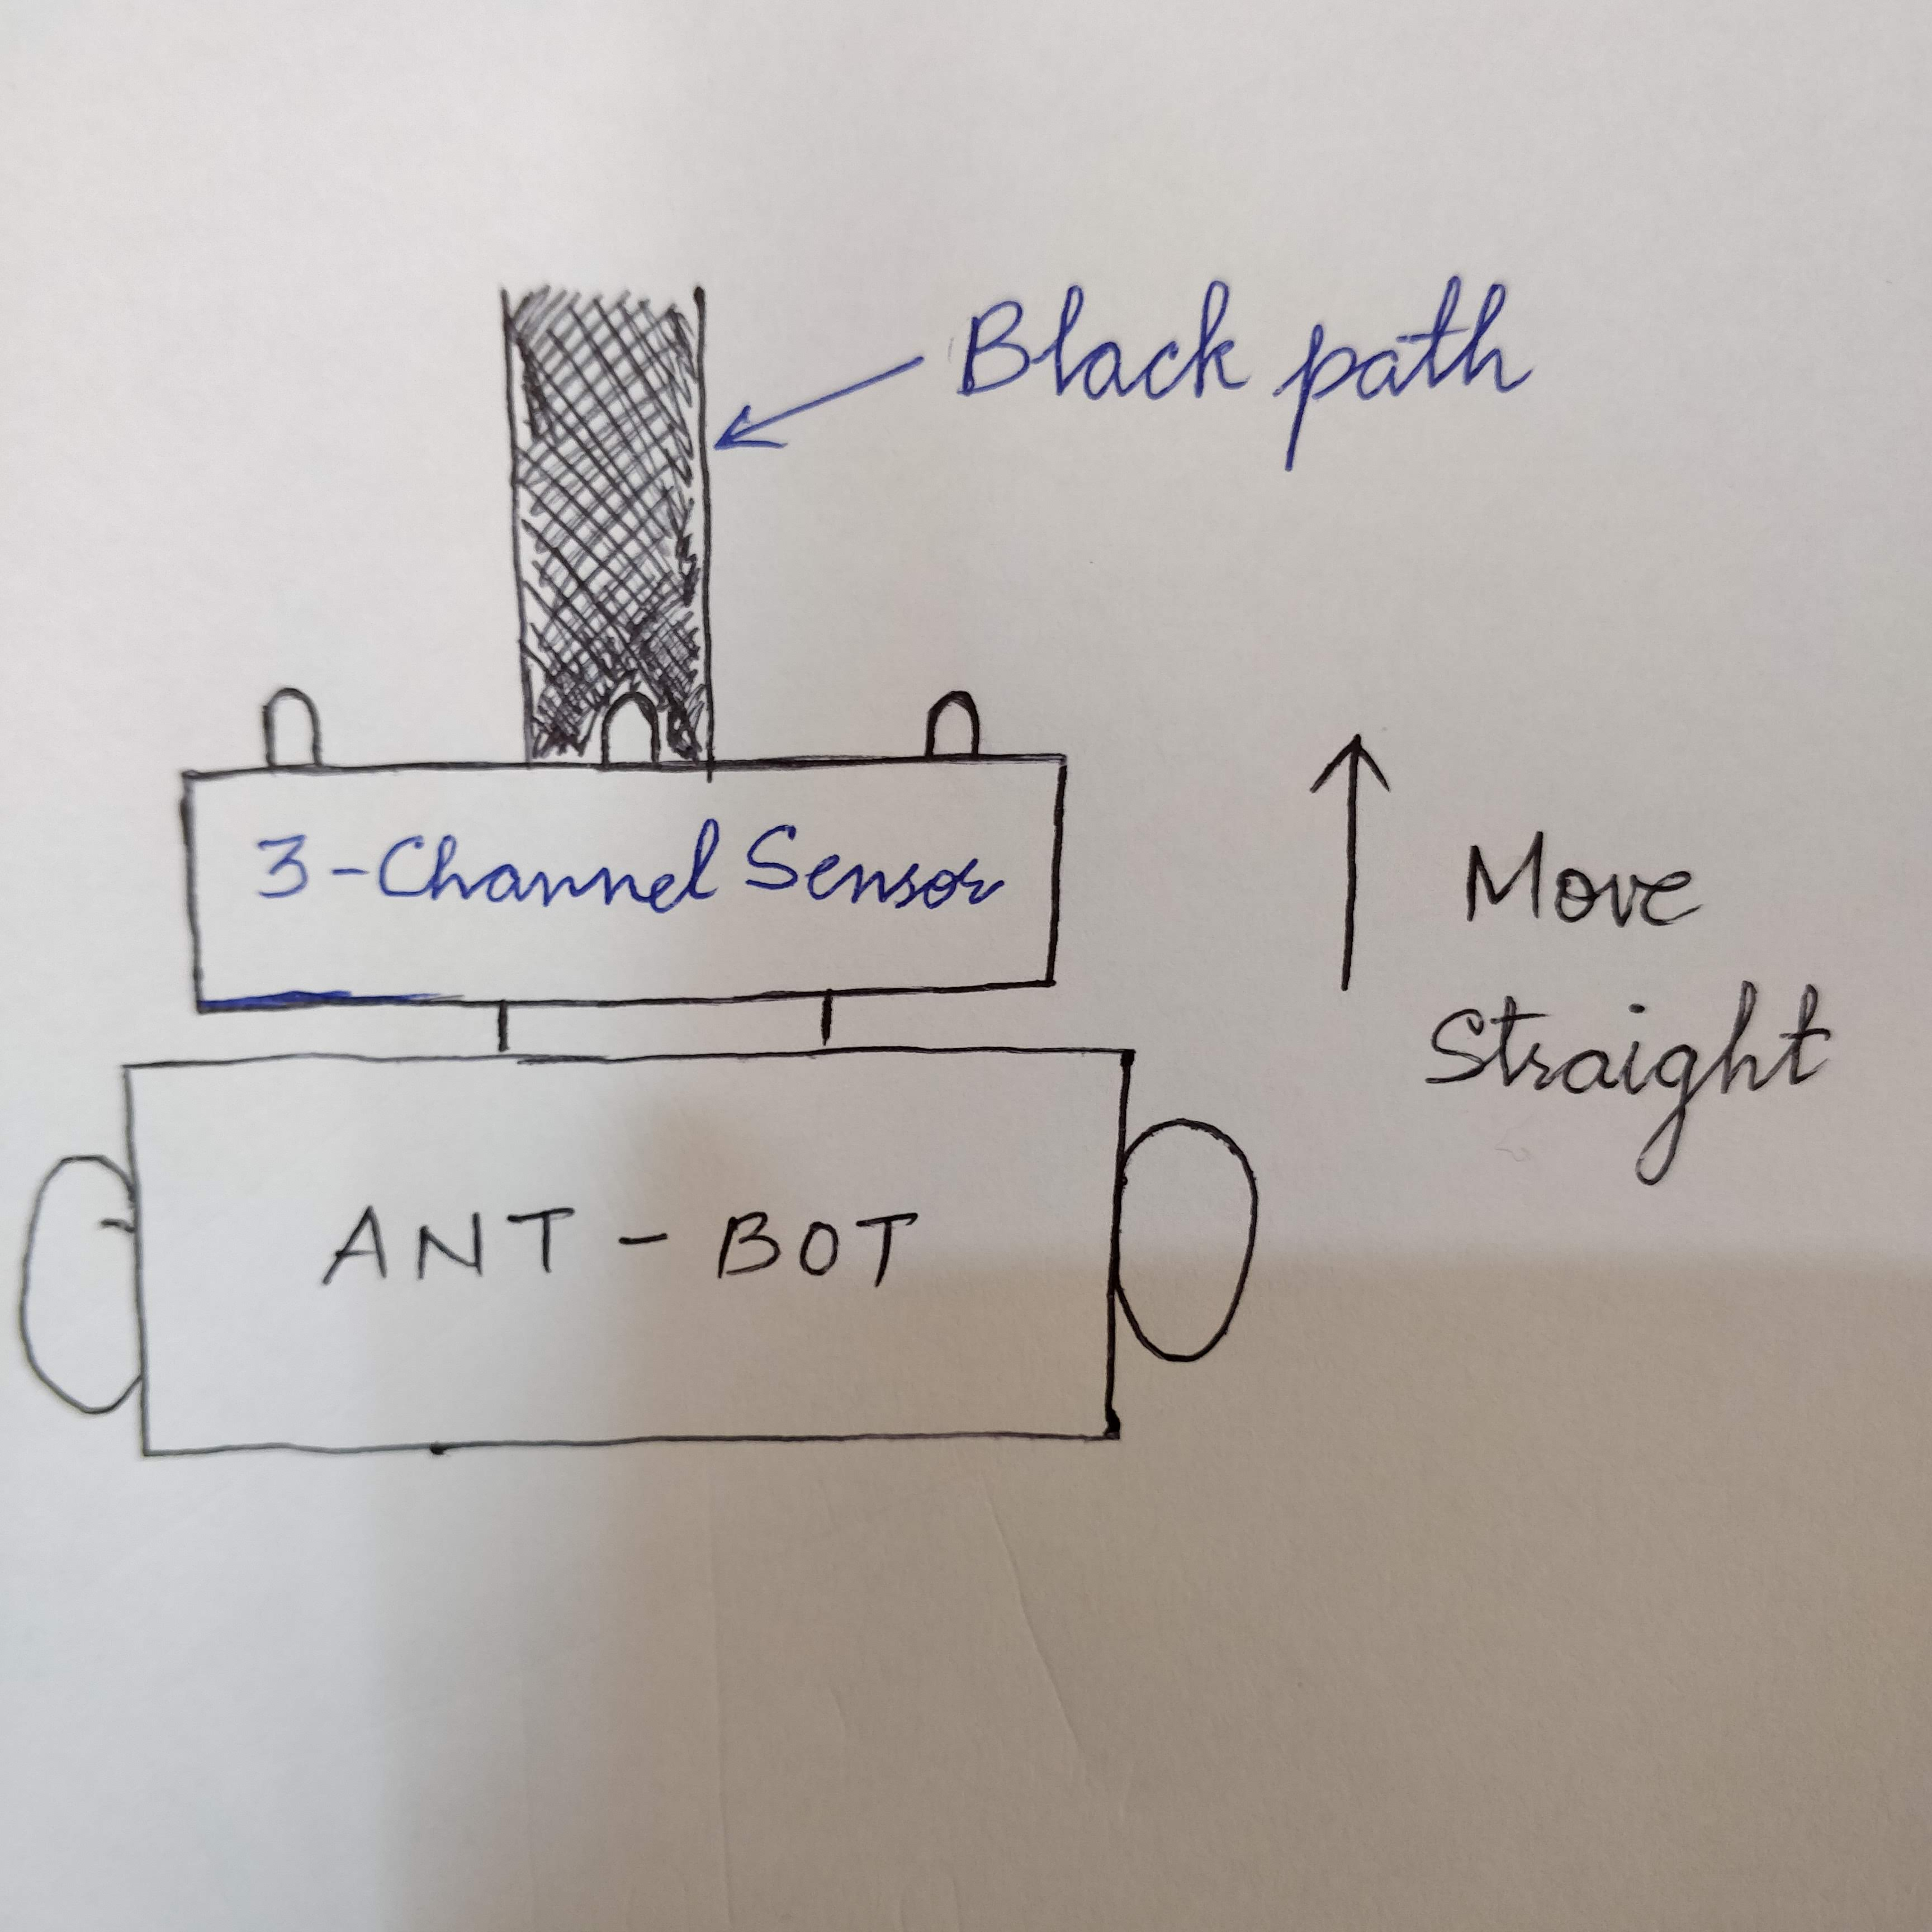

1. Now if for some reason the direction of the ant-bot changes and it’s not moving ‘along’ the path, for example in the figure given below, the ant-bot shifts right.

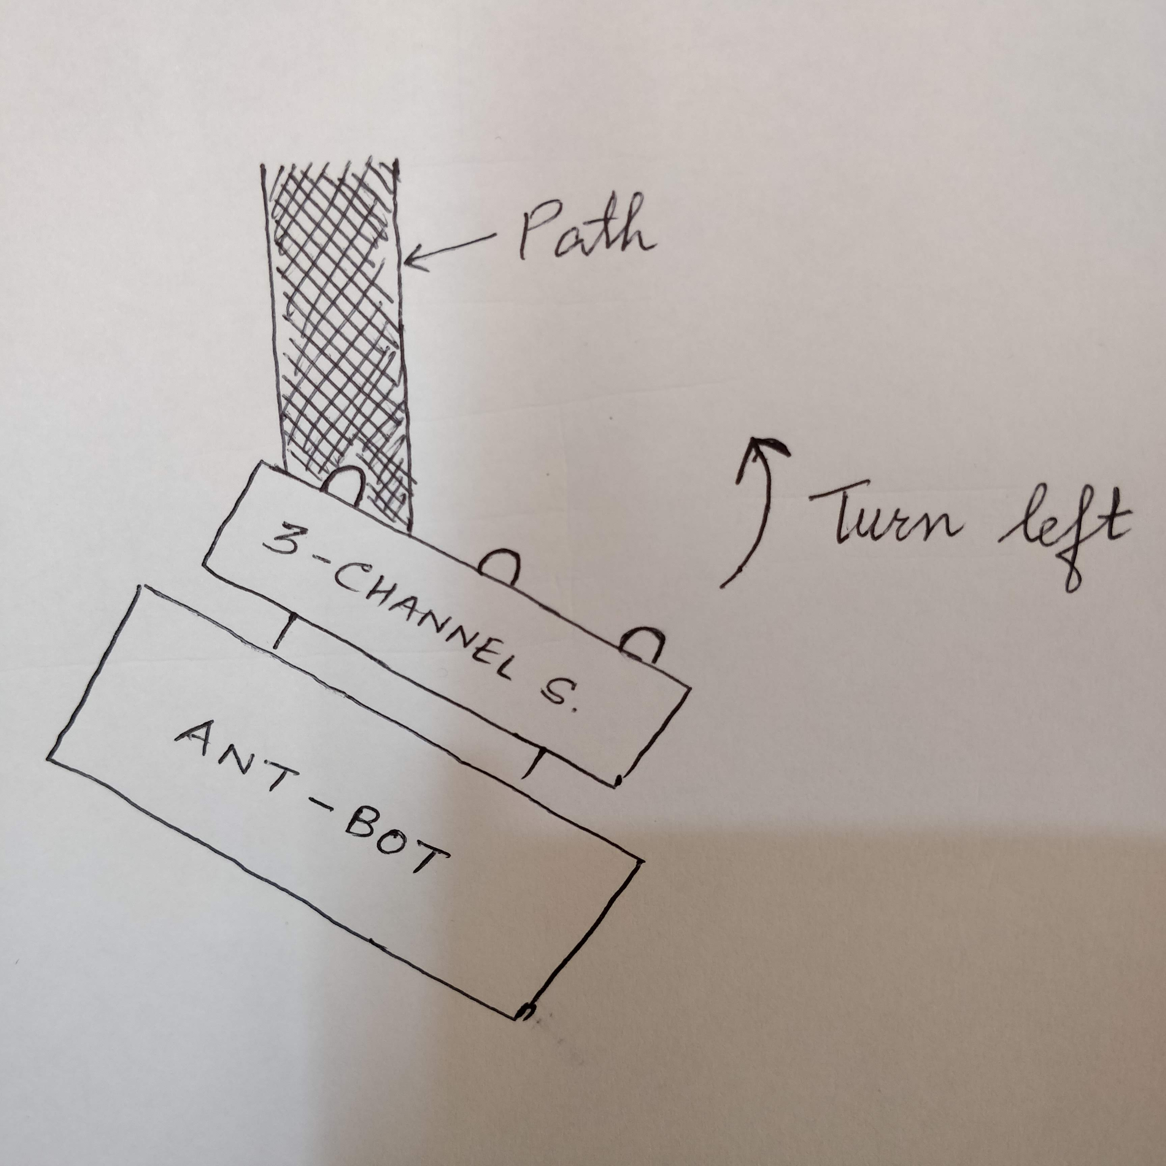

If left sensor comes on black line then robot turn left side.

1. Similarly, if the ant-bot shifts left, then the right sensor will come on the black path.

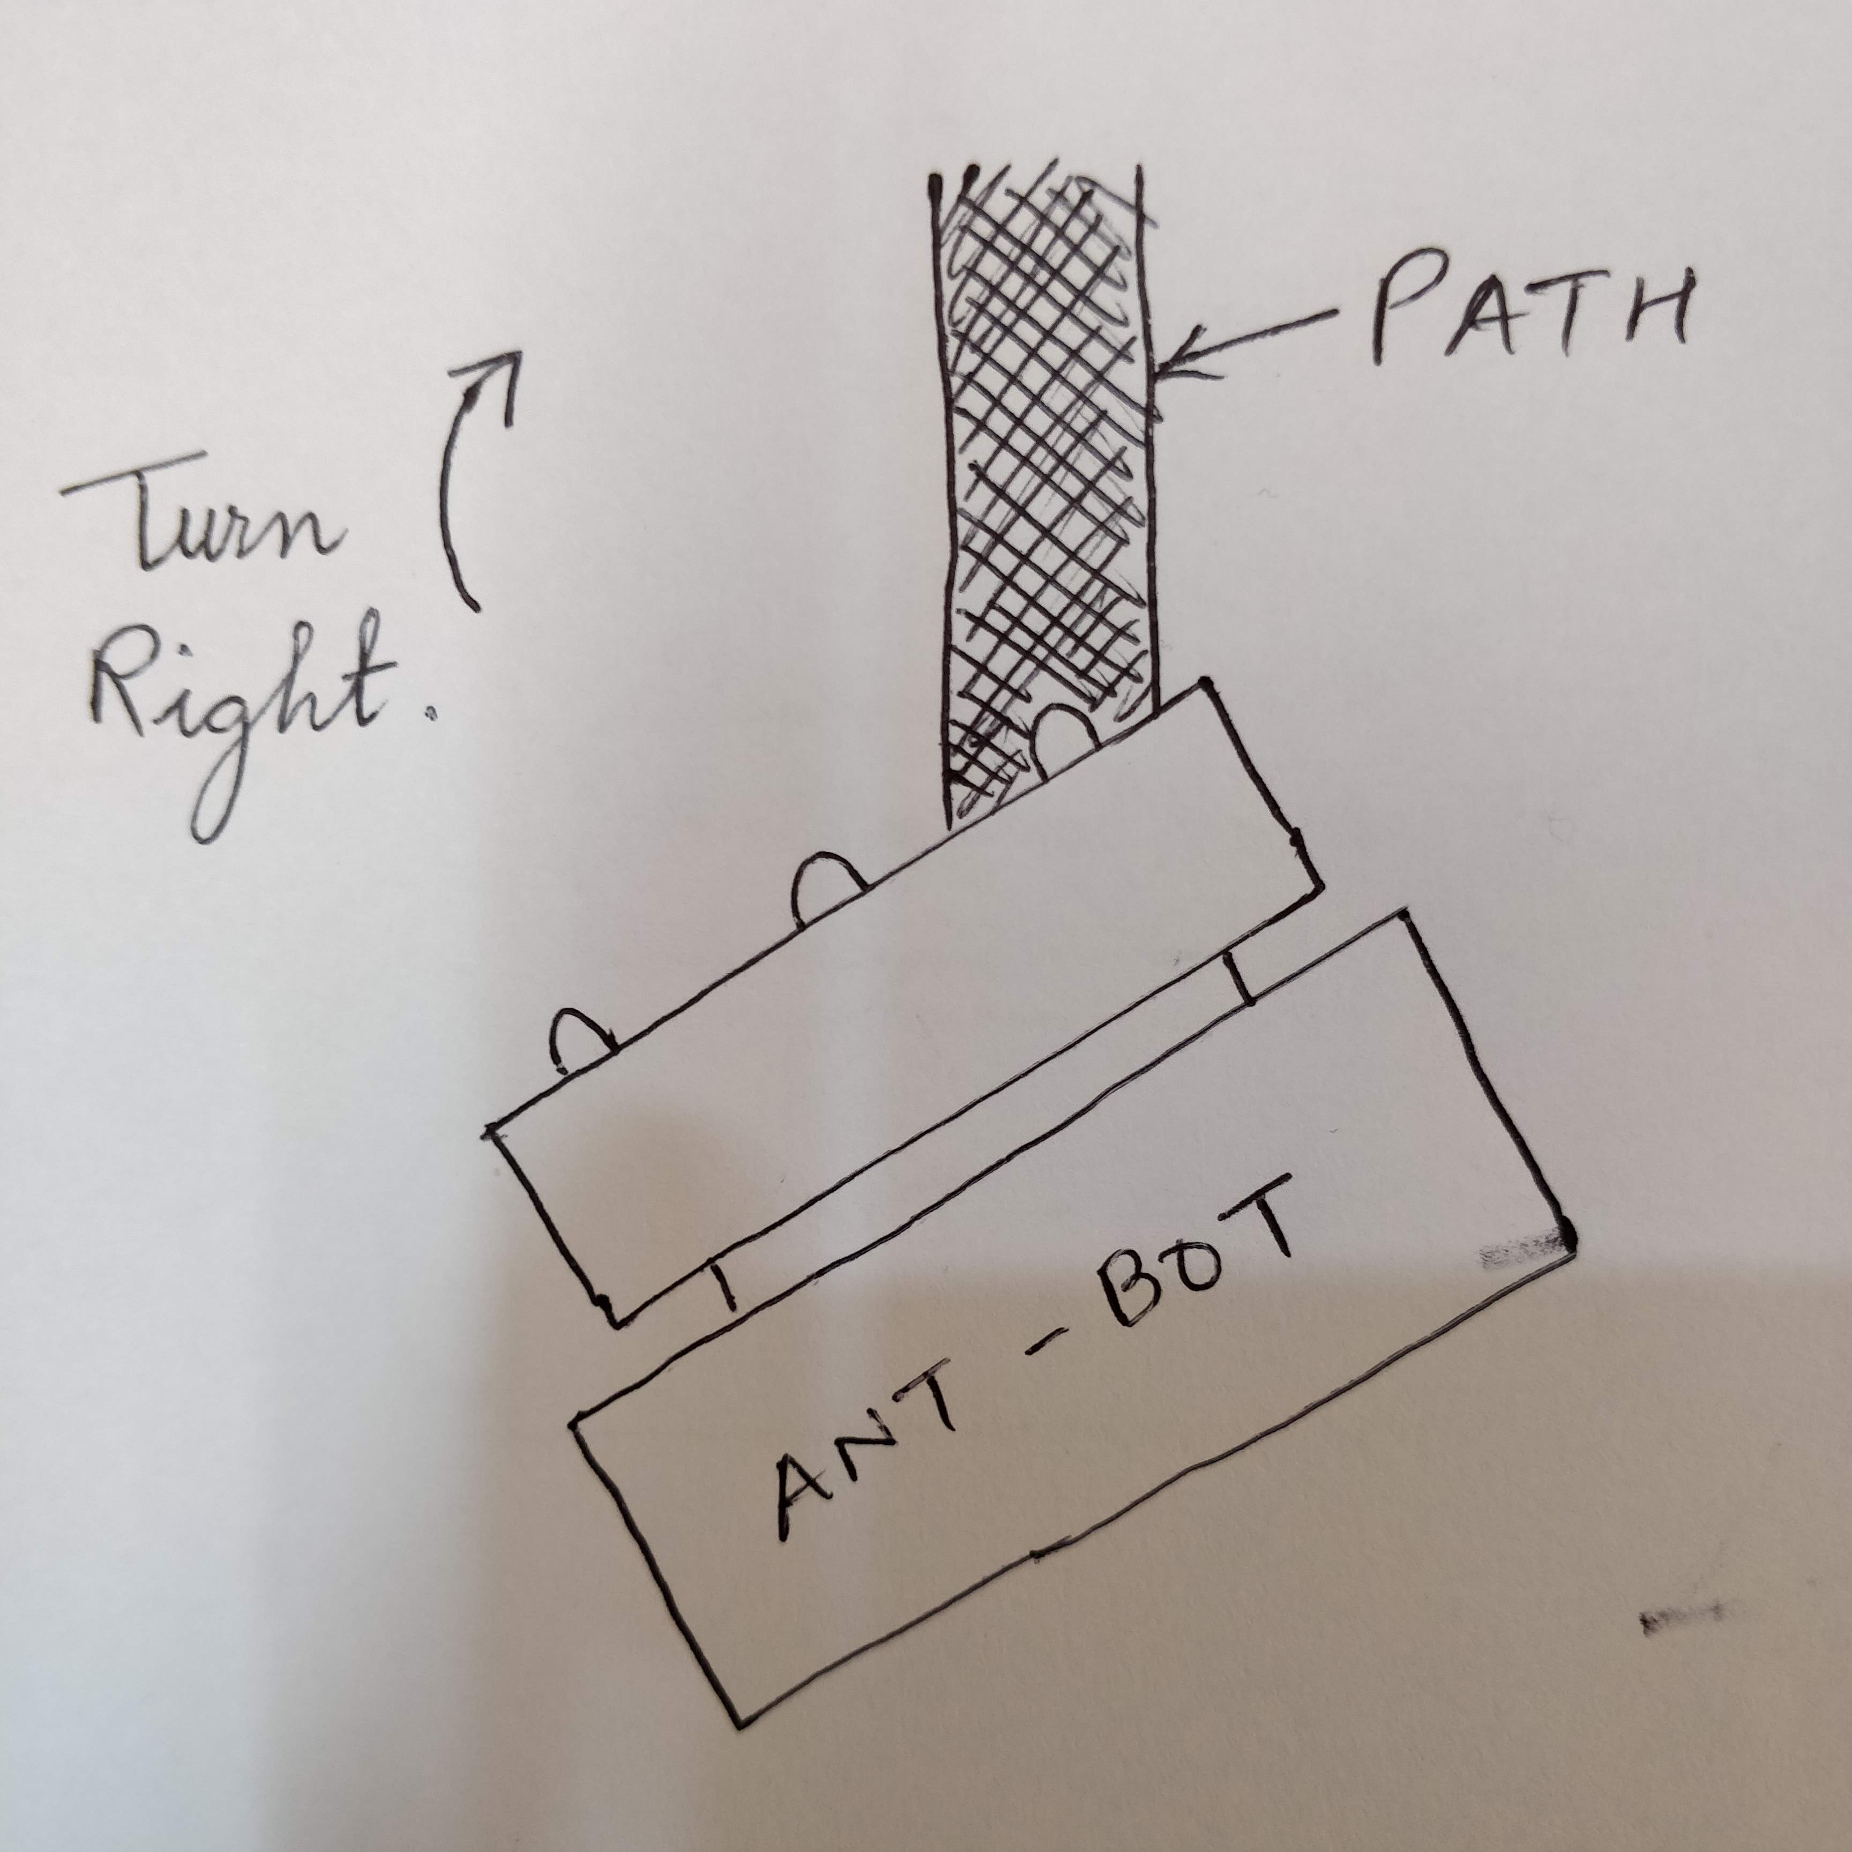

And hence, we will have to turn the robot right side.

1. When the ant-bot encounters a node, all the 3 channels of the sensor will be on the black path/line. In such a case, the bot will stop and the algorithm will decide in which direction, i.e. left, right or straight, should the ant-bot move.

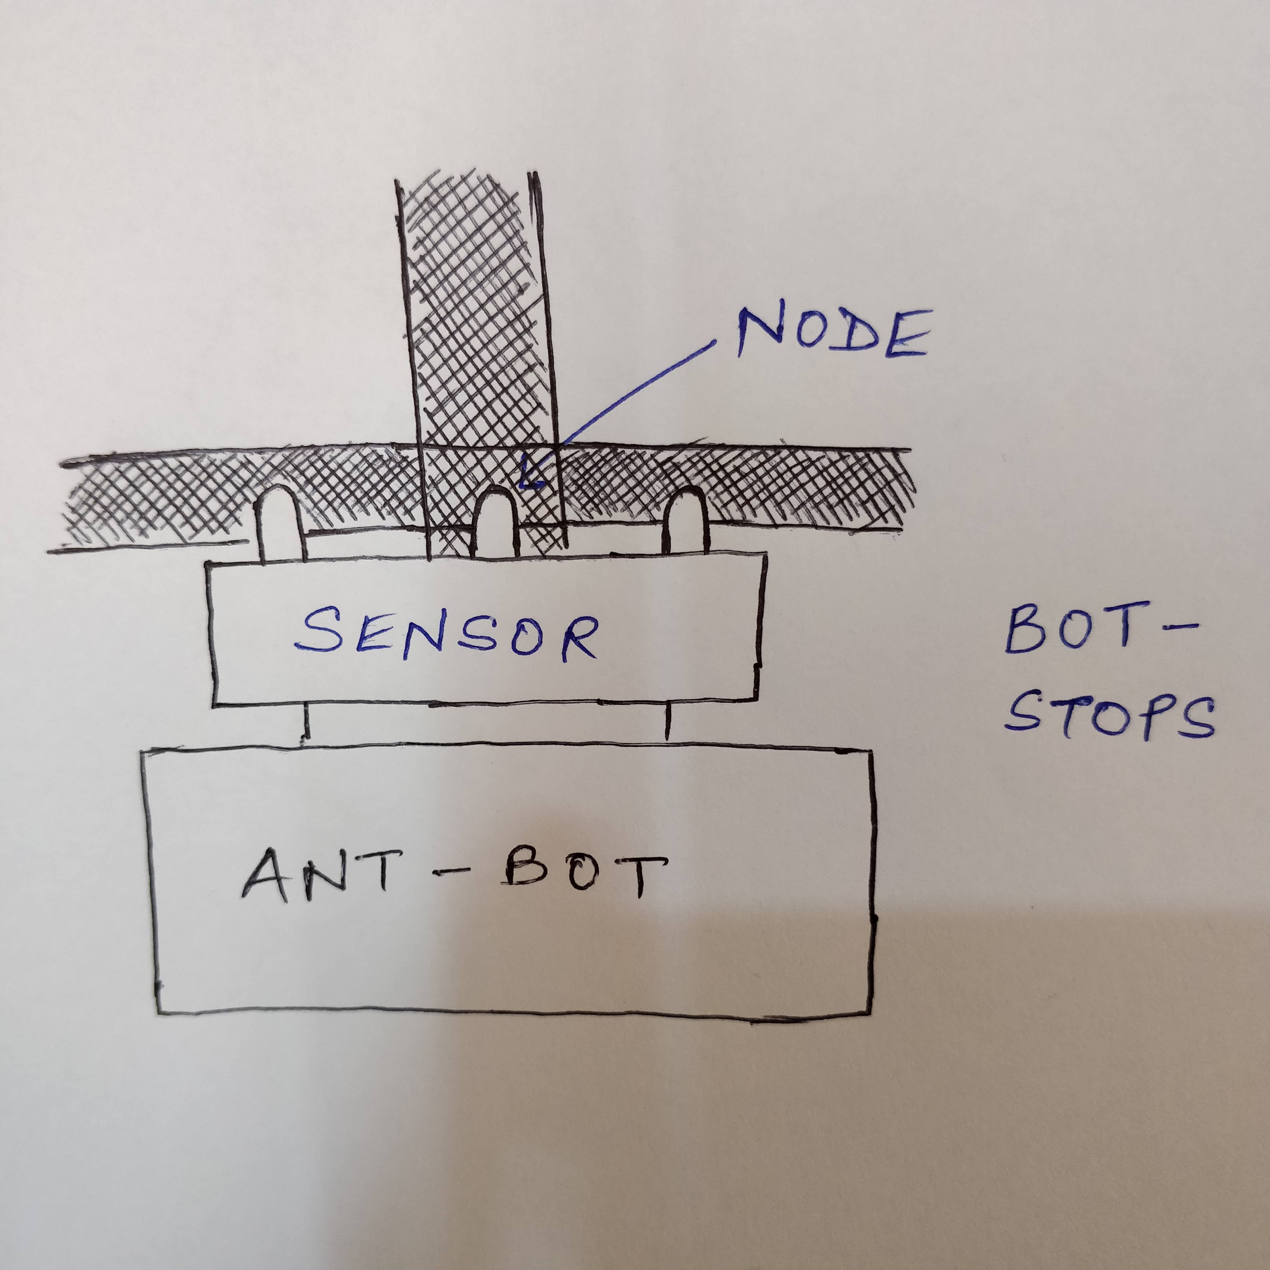

**b. Would the webcam be a better choice of camera over the PiCam? Explain.**

**(5)**

**PiCam:**

**Advantages: -**

1. A Pi camera is run by the Graphical Processing Unit (GPU). No CPU interaction is required.
2. It can load complete frames in the RAM at 15 frames per second (fps) i.e. 112.5 Mega Bytes per second as each frame costs 7.5MB.
3. Hence, full HD resolution 30 fps encoded by GPU and some continuous still photos, all this with virtually zero CPU loading cost. Therefore, better resolution.
4. Less resource intensive.
5. Compact

**Disadvantages: -**

1. No camera stand.
2. Short connection length.
3. Can’t focus manually.

**Web Cam:**

**Advantages: -**

1. It has long USB wire for easy movement.
2. 2 fields of view, close and kind of close.

**Disadvantages: -**

1. The web camera is run by the Central Processing Unit with single byte at a time.
2. It uses 100% CPU loading cost to get some hundreds of Mega Bit per second.
3. In case we are delivered that much frames by the CPU, then we won’t have any cycles left for other applications.

**CONCLUSION:**

In our ant-bot theme, we require to capture the supply/trash blocks and the ArucoID’s as clearly as possible. Since the resolutions provided by the webcam is 320x240 pixels, it is not very clear. Hence, we use picam which is equipped with 5MP camera and can provide us 15 fps images.

**c. What other sensors will the robot require to complete its task successfully?**

**(5)**

*No other sensor required.*

In out ant-bot theme, no other sensors are required apart from those provided in the kit.

1. For traversing the black path, we have the ‘***Line following sensor’***.
2. For detecting the supply/trash blocks and SIM’s, we have ***PiCam.***

**d. Explain the strategy you will follow to detect and indicate the SIM placed around the Central Node (This includes traversing strategy to reach different SIMs).**

**(4)**

**Detection and indication of SIM in the arena:**

**Strategy 1:**

1. The ant-bot will start moving from the start position and will reach the central node.
2. From the central node, the picam will be extended over the ArUco ID’s with the help of actuators.
3. Once a picam successfully captures the ArUco ID, the actuator will move the picam to the other SIM.
4. We are going to start from SIM0, then SIM1, SIM2 and lastly SIM3.

**Strategy 2:**

1. Once we reach the central node, we will move left such that we are at minimum distance from the ArUco ID on both sides.
2. We will stop there and take a picture of the Aruco ID at SIM0 from above with the help of picam and actuators.
3. After successfully capturing the image, we will do the same for SIM3.
4. After we have scanned SIM0 and SIM3, we will traverse back to central node and to the same for SIM1 and SIM2.

In this way, we can have all the 4 SIM’s scanned.

**Testing your Understanding (Theme Analysis and Rulebook-related)**

**Q6. a. If at a given SIM location ArUco ID is found to be 76 (Decimal), what is the Ant Hill Number and type (Regular Ant Hill or Queen Ant Hill) and what are the Service Requirements of this Ant Hill?**

**(3)**

Given ArUco ID = 76, therefore we have

1. **Ant Hill Number:**

AH2

1. **Ant Hill Type:**

Regular Ant Hill (RAH)

1. **Service Requirements:**

Service 1 -> Leaves

Service 2 -> Honey Dew

Trash (TR) service is not required.

**b. Is SIM0: 25, SIM1: 60, SIM2: 217, SIM3: 226, a possible combination of SIMs to be placed on the arena? If not explain with reasons.**

**(3)**

For SIM0: 25,

Ant Hill Number:  **AH0**

Ant Hill Type: **RAH**

Service Requirements:

1. Serv1 -> No supply
2. Serv2 -> Wood

TR required

For SIM1: 60,

Ant Hill Number:  **AH1**

Ant Hill Type: **RAH**

Service Requirements:

1. Serv1 -> Leaves
2. Serv2 -> Wood

TR not required

For SIM2: 217,

Ant Hill Number:  **AH2**

Ant Hill Type: **QAH**

Service Requirements:

1. Serv1 -> No supply
2. Serv2 -> Wood

TR required

For SIM3: 226,

Ant Hill Number:  **AH3**

Ant Hill Type: **QAH**

Service Requirements:

1. Serv1 -> Honey Dew
2. Serv2 -> No supply

TR not required

**CONCLUSION:**

As we can see, the ‘Ant Hill Type’ for SIM2 and SIM3 is the same i.e. ***‘Queen Ant Hill’.***

Since in our ant-bot theme, there can only be one ‘Queen Ant Hill’ given at a time in a particular arena, therefore, we can say that *it is not possible to place the given combination of SIM’s on the arena.*

**Reason : More than two Queen Ant Hills present in the given arena at the same time.**

**c. What are the different conditions that indicate end of a run?**

**(3)**

The conditions that indicate the end of a run are:

1. The Ant-Bot completes the task and turns ON the buzzer at “Start” position for 5 seconds.
2. The maximum time limit (600 seconds) for completing the task is reached.
3. The Ant-Bot needs repositioning but has used maximum allowed repositioning options of that Run.

**Algorithm Analysis**

**Q7. Draw a flowchart illustrating the algorithm you propose to use for theme implementation.      (10)**

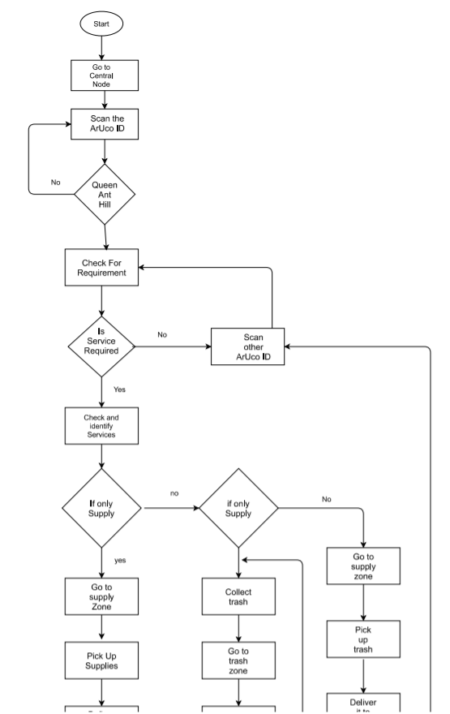

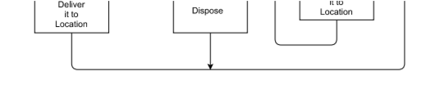

**Q8. Suppose for a given arena configuration, it takes 20 seconds more to execute the task while keeping the Queen Ant Hill in priority. What will be your logic to traverse the arena in order to secure maximum marks i.e. you will serve Queen Ant Hill first by taking 20 seconds more or complete the run faster by not serving Queen Ant Hill first (Assuming, points scored for all other parameters in Total Score in both the cases remain same). Please explain and justify your logic and strategy.**

**(4)**

We will complete the run faster by not serving Queen ant hill first because according to the flow chart it will require less time to scan the regular ant hill than to keep searching for the Queen ant hill. If we go for Queen ant hill first then for the worst case scenario, the aruco marker will be scanned three more times which will take extra time. We can avoid this by our plan of action. Our strategy will reduce the task completion time.

**Challenges**

**Q9. What are the major challenges that you can anticipate in addressing this theme and how do you propose to tackle them?**

The major challenges which we can face are:

1. **Supply blocks not being placed properly in the required supply boundary in the ant-hill.** We need to place the supply blocks as perfectly as possible so that it doesn’t cross the boundary. But it might happen that the ‘pick and place mechanism’ wouldn’t pe too precise in this task. Hence, we need to take extra care to place it correctly.

*Preferred solution:*

1. *We’ll use optimal length of the gripper arm such that when the ant-bot is at the end of path near the placing area, the arm wouldn’t require much change to place the block correctly within the boundary.*
2. *While placing the blocks, we’ll try as much to bring the gripper arm to the ground as possible. In this way, the chances of the blocks being stumbled will decrease significantly.*
3. **Lifting supply/trash blocks properly.**

While lifting the blocks it might happen that they may slip or wouldn’t pe easily picked up. They would drift away from the gripper arm.

*Preferred solution:*

1. *Try to use better quality material for the gripper with a high friction value.*
2. *We can also try to use another form is picking up like lifting from above.*
3. *Since in our ant-bot theme, the supply blocks are cube shaped, we can use L-shaped clamps for giving a firm grip rather than using other curved grippers.*
4. **Picture captured by PiCam is not clear enough.**

While capturing an image of the ArUco ID’s, it may get blurred or might not be clear enough to be detected by the program correctly.

Also, while scanning the supply/trash blocks the recognition rate could be slower/wrong depending upon the image quality.

*Preferred solution:*

1. *We would capture more than one image of a particular ArUco ID. Now we will run the detection algorithms on all the images and will compare all the outputs. The output with the majority vote will be used futher.*
2. With the use of actuators, we can move the picam at different angles and capture images accordingly. Hence, comparing and testing the resultant outputs would become more accurate.